Outline for paper on modeling the effect of temperature on fish growth in the California Current

(*Assignment and dates are for first drafts of text*)

Authors (tentative): Paul, Tara, Alan, Tim, Christine, Melissa (and other from ToR 1)

**Introduction**

The somatic growth of individual fish, from larval to adult stages, underpins the size structuring of aquatic ecosystems and is also subject to environmental influences (Black 2009). Growth is an inherently non-linear process resulting from dynamic fluxes between anabolism and catabolism (Quinn and Deriso 1999). Consequently, abrupt changes in growth rates can occur throughout the lifespan of an individual fish, most notably during the transition between the rapid growth of juvenile stages and the slower growth during adult stages (Lester et al. 2004, Quince et al. 2004). Dynamic changes in size-at-age can have direct impacts on rates of harvest and fishery management reference points because fisheries management is often based on limiting mortality (i.e., based on abundance) via biomass-based harvest quotas and the assumption of an average growth relationship through time, (Miller et al. 2018). However, if growth fluctuates well above or below the long term average growth relationship then realized biomass-based harvest quotas may be lower or higher than quotas set as a function of an average growth relationship. The dominant patterns in and magnitudes of somatic growth variation over long time scales have not been quantified for many commercially important fish stocks (Stawitz et al. 2015). Therefore, quantifying the basic characteristics and dominant scales of variation in growth is the necessary first step towards predicting growth responses to biotic and abiotic factors (Stawitz et al. 2015).

Individual growth rates vary on a range of temporal and biological scales, including across species and populations of the same species (Brander 1995, Brunel and Dickey-Collas 2010). Within a given system, variation in size-at-age may occur between cohorts of a single population (Baudron et al. 2011, Baudron et al. 2014), between years, or between juveniles of cohorts (Stawitz et al. 2015). Understanding the variation in size-at-age can help refine mechanistic hypotheses. Density-independent annual changes in growth may occur from processes such as upwelling, affecting all ages within a year. Alternatively, density-dependent processes such as intracohort competition may affect strong cohorts; in this case, environmental processes that lead to strong recruitment may result in reduced growth rates (Whitten et al. 2013). A third mechanism is that variability in growth is related to only the size-at-age of juvenile fish, with growth rates of older ages unaffected by the environment, which is consistent with juvenile intracohort competition being the dominant process. Stawitz et al. (2015) examined these hypotheses for North Pacific groundfish, and found that about 40% of the stocks studied showed density-independent annual growth variation between years.

Because temperature is an important determinant of growth for ectothermic species, the temperature size rule (TSR) provides the basis for an important hypothesis relevant to climate change. The temperature size rule (TSR) proposes that juvenile growth rates are higher in warmer waters due to higher metabolic rates with rapid early growth leading to a lower maximum (adult) size-at-age (Angilletta et al. 2004, Daufresne et al. 2009, Forster and Hirst 2012, Forster et al. 2011). In the context of warming regional seas, the TSR has the potential for imposing a low-frequency signal into variability in individual growth rates of fish. For example, warming temperatures in the North Sea imposed a synchronous cross-species trend in growth rates of 6 of 8 commercial fish stocks consistent with the TSR (Baudron et al. 2014). A combination of temperature-related reductions in body size and distributional shifts has been estimated to reduce fisheries yields by as much as 25% (Cheung et al. 2013).

The von Bertalanffy growth function (VBGF; von Bertalanffy 1938), developed from physiological concepts such as catabolism and anabolism (Essington et al. 2001), can be used to test how temperature may affect size-at-age and potentially particular aspects (e.g., parameters) of the growth process. Simple correlations between temperature and the VBGF have been undertaken (Brunel and Dickey-Collas 2010), an approach that would require temperature impacts to be strong relative to other sources of variation. Adaptations of the VBGF have been developed to incorporate the effect of temperature and other environmental factors directly into the VBGF parameters L∞ (asymptotic size) and *K* (rate at which L∞ is approached) (Fontoura and Agostinho 1996, Shin and Rochet 1998). Kimura (2008) developed an extended form of the VBGF which could include any explanatory variable as a covariate, which (Baudron et al. 2011) used to determine that temperature was a statistically significant covariate in the cohort-specific VBGF fit for North Sea haddock stock. Although the VBGF has the advantage of allowing consideration of how environmental variability affects specific aspects of growth, estimation of changes in both the k and Linf parameters is difficult because they are highly correlated (Schnute and Fournier 1980).

Rapid and variable local responses of fish size to warming can also make temperature responses difficult to diagnose and predict at the ecosystem scale (Audzijonyte et al. 2020). Testing for a coherent (*sensu* consistent with established physiology of ectotherms and widely observed across different species) biological response to temperature at the ecosystem scale requires using a statistical model suited to isolating the impacts of a single, external factor (i.e., temperature) on fish growth rates in addition to other possible sources of variation (e.g., density, prey abundance, fisheries-induced changes in life history). Coherent and synchronous annual growth trends across species that are consistent with physiological principles (e.g., TSR) would imply there is a component of growth variation that is a shared response to ecosystem-scale warming (Baudron et al. 2014, Stawitz et al. 2015). Isolating such a response at the stock- or ecosystem-level would provide the necessary empirical support for models developed to forecast future fish yields (e.g., Cheung et al. 2013).

Because ecosystem observations do not come from controlled experiments in which variables of interest can be isolated, more complex statistical methods will be necessary to evaluate any potential coherent, cross-species signal in the effect of temperature on growth. An additional consideration is whether to model observation errors, which is particularly relevant because the data available are typically observations of size-at-age from individual fish (i.e., multiple observations of size-at-age from a single fish that would more clearly show individual growth are typically not available). Temporal trends in size-at-age data could reflect trends in gear selectivity, sampling locations, ageing bias and precision, and other factors. A closely related concept is whether to employ Bayesian or random-effects methods that would model observations and/or estimated parameters as random variables. For example, changes in sampling location or the effect of environmental covariates on size can be modeled as random variables to account for unobserved heterogeneity not explained by the structural model.

A variety of advanced statistical techniques have been applied recently to evaluate variation in fish size-at-age. (Baudron et al. 2014) used Dynamic Factor Analysis (DFA; Zuur et al 2003) to estimate common “latent” trends in the cohort-specific *L∞* time series for eight North Sea stocks with long time series of size-at-age. DFA is a multivariate extension of structural time series, with the time series for a particular stock being a function of underlying latent trends and stock-specific observation error. An alternative framework applied by (Stawitz et al. 2015) are autoregressive state-space models consisting of process and observation models that fit to observed time series of standardized length-at-age data without a mechanistic growth model. Miller et al. (2018) also used a state-space model, but the process model is based on a generalized VBGF that allowed process errors in the *k* parameter. Finally, spatio-temporal models such as VAST (Vector Autoregressive Spatio-Temporal model; [www.github.com/james-thorson/VAST](http://www.github.com/james-thorson/VAST)) are mixed-effect models in which model spatial variation as random effects given a pattern of spatial correlation, and a number of covariates can be modeled as fixed effects. Although VAST models are often applied to data on fish density from resource surveys (Thorson 2019), they can be potentially useful for cases where fish size-at-age may vary over space in patterns not related to the modeled fixed effects.

An alternative framework that has been applied to modelling individual growth is autoregressive state-space models that compare the relative importance of different scales of variation (e.g., annual, cohort) and extract underlying growth trends across species (Stawitz et al. 2015). State-space models simultaneously estimate model parameters using two equations: the autoregressive process representing abiotic and biotic covariates and the unobserved processes including space and time covariates.

The inferences that can be made regarding how temperature affects fish growth are influenced by the choice of model structure. In particular, evaluation of a series of models may help illuminate modeling approaches that have utility when any coherent response of fish growth to temperature may be subtle relative to asynchronous or stock-specific factors (e.g., food availability, density). Although the models mentioned above all have a common property of recognizing variation other than the “process” variation of interest, they apportion variance very differently because of differences in model structure. Multi-model inference is the process whereby the response variable is estimated using several candidate models rather than a single ‘best’ model (Burnham and Anderson 2002) and has been previously applied to growth modelling (Katsanevakis and Maravelias 2008). In our study the intent was not necessarily to predict the response variable with the greatest accuracy but to identify the modelling framework(s) best suited to assessing whether there was a synchronous impact of temperature once other sources of variation have been accounted for (state-space models) or once asynchronous sources of variation had been excluded (DFA). Comparative analysis of models can also help to identify biases in model performance (e.g. whether a model systematically underestimates random noise in the data) or shortcomings in model fitting (e.g., estimation of process or observation error). For example, Brodie et al. (2020) compared several types of species distribution models and identified which models were appropriate for specific purposes. Ultimately model purpose must be given due consideration when deciding on the most appropriate modelling framework (Brodie et al. 2020, Guillera-Arroita et al. 2015).

The aim of this study is to undertake a comparative analysis of four models using empirical data for temperature and size-at-age for seven fish stocks in the California Current large marine ecosystem. A common metric for the models is to evaluate the degree to which size-at-age is related to temperature. Estimates of uncertainties, parameter correlations, and any potential aliasing (i.e., erroneously attributing variation size-at-age to non-causal mechanisms or covariates). We consider the relative strength and weakness of the models in describing how temperature may affect size-at-age, and how the combination of models can be used for multi-model inference.

**Methods**

1. Study area, species chosen, trawl survey description (*Melissa, Feb 29)*

Four trawl surveys conducted by the National Marine Fisheries Center’s Alaska Fisheries Science Center (AFSC) and Northwest Fisheries Science Center (NWFSC) provided data for this study. The Triennial Shelf Survey, conducted by the AFSC in 1980, 1983, 1986, 1989, 1992, 1995, 1998, and 2001 and by the NWFSC in 2004, provides the earliest time series of fishery independent temperature and biological data in the U.S. portion of the California Current continental shelf (Weinberg et al. 2002). Triennial survey sampling occurred along transects perpendicular to the coast over depths from 55 m to 366 m (500 m after 1992) and from the Canadian border to Monterey Bay, California (36°48' N) until 1986, then to Point Conception, California (34°30' N) from 1989 forward.

The transect-based AFSC Slope Survey was conducted in 1997, 1999, 2000, and 2001, over depths from 184 m to 1,280 m in waters north of Point Conception, California (34°30' N) to the US – Canada border (Lauth 1999, 2000, 2001). Sampling in earlier years was spatially limited, covering small and inconsistent portions of the coast; however, this survey had a high degree of biological sampling.

The transect-based NWFSC Slope survey, conducted in 1998, 1999, 2000, 2001, and 2002, covered depths ranging from 184 m to 1,280 m using chartered commercial fishing vessels <93 feet (Keller et al. 2017). Prior to 2000 the NWFSC Slope survey sampled from the Morro Bay, California (lat 35°00'N), to the U.S.–Canada border, the survey area was expanded south to Point Conception, California (34°30' N) in 2001, then to the U.S. Mexico border in 2002. This survey consists of fewer tows compared to other survey data sets, with a lower fraction of tows sampled for ages.

The NWFSC West Coast Groundfish Bottom Trawl Survey (WCGBTS), operating annually from 2003 through 2019, implements a stratified random-grid survey design that spans both continental shelf and slope habitats, depths from 55m to 1,280 m, and covers U.S. waters between the Canada and Mexico borders (Bradburn et al., 2011, Keller et al. 2017). Strata include three depth strata (55 m to 183 m, 184 m to 549 m, and 550 m to1280 m) and two spatial strata (north and south of Point Conception, California (34°30' N)) for all years except 2003. In 2003 five spatial strata delineated by the boundaries of the International North Pacific Fisheries Commission (INPFC) statistical areas were used. These INPFC statistical areas are, from north to south, Vancouver, Columbia, Eureka, Monterey, and Conception. Generally, four chartered industry vessels conduct tows from late-May to early-October, in randomly selected grid cells, during two north to south passes along the U.S. west coast. Randomly sampled lengths and ages are collected; age structures are sampled from a subset of the fish that have been measured for length. Major changes in the WCGBTS, compared to prior surveys, include implementing a stratified random survey design and consistent spatial coverage south of Point Conception, California (34°30' N).

Regions used in this study are a combination of the 2003 WCGBTS latitudinal and depth strata. The INPFC Vancouver, Columbia, and Eureka latitudinal strata are combined into a single region, labeled “ECV”, due to ecological similarity. The combination of three INPFC latitudinal strata and three depth strata yield nine regions defined by latitude and depth. Mean bottom temperature used *in situ* data from the four surveys for each of the nine region-year strata with at least five observations, with data from the AFSC slope survey restricted to September – October to provide a similar sampling period to the remaining surveys (i.e., May – October).

Seven species were selected for analysis of length-at-age data, based on a diversity of life-history traits, habitat usage, and data availability. Length-at-age data for two deep-water species with ranges encompassing both the continental shelf and slope (darkbloched rockfish (*Sebastes crameri*) and sablefish (*Anoplopoma fimbria*)) were obtained from two surveys that collectively cover the full depth range of these species in a given year: the Triennial Shelf Survey and NWFSC Slope surveys for years 1998 and 2001, and the WCGBTS for the years 2003 to 2018. Shortbelly rockfish (*Sebastes jordani*) also occur on the slope and shelf, but limited observations restricted analysis to data from the WCGBTS. Length-at-age data for four species that occur on the continental shelf (Pacific hake (*Merluccius productus*), Pacific sanddab (*Citharichthys sordidus*), lingcod (*Ophiodon elongatus*), and petrale sole (*Eopsetta jordani*)) were obtained from two surveys: the Triennial Shelf Survey and the WCGBTS. Because marine fish stocks often change the depth and spatial locations occupied as they age, we attempted to derive temperature time series reflective of the habitats they occupy at a given age. We used the species-specific set of surveys listed above to compute the mean depth and latitude of the length-at-age samples by age (for ages 0 – 15) across years, then classified these means into the nine latitude-depth regions. The temperature time series for a given species and age was obtained from the corresponding latitude-depth region where they occurred.

1. Brief methods of the 4 models (note specifically how the models relate to the hypotheses mentioned above on fish growth)
   1. Stawitz state-space model (*Christine, Feb 29)*

*State-space growth models*

We used the same general model as Miller et al. (2018) which assumes von Bertalanffy growth and allows annual age-specific growth rates. It can use combinations of length and weight information and simultaneously estimates allometric length-weight relationship. We fit four alternative models for each species (Table 1). The base model assumes the same LVB growth rate and asymptotic size for all individuals. The second model allows annual AR(1) deviations in the log growth rate for a given year applied to all cohorts in that year. Allowing this AR(1) process for annual growth rates was found by Miller et al. (2018) to be important for evaluating effects of temperature on growth rates for Georges Bank Atlantic cod. The third model expands the second model to include temperature effects on the growth rate during the first year of life. The fourth model expands the third model to allow different asymptotic lengths for cohorts originating after 2000 when there was a dramatic reduction in fishing pressure (Warlick et al. 2018).

For darkbotched rockfish, sablefish, and shortbelly rockfish we used length, weight and age observations from the “combination survey” only, whereas for hake, sanddab, lingcod, petrale sole we used observations from both the “combination” and “trienniel” surveys. The total number of length and weight at age observations available for each species ranged between 5152 for shortbelly rockfish and 17850 for sablefish. For models and , we used the bottom temperature estimates for the region defined by area and depth bin where the species was predominantly found during the earliest observed ages (Table 2). We observed age 0 fish for all species except Petrale sole (minimum age is 1), and the youngest observed ages of all species predominated in depths less than 184 m. Young sablefish and darkblotched rockfish predominated in the most northern region (Eureka-Columbia-Vancouver) and young shortbelly rockfish predominated in the most southern region (Conception). Young fish of all other species predominated in the intermediate region (Monterey).

Table 1. Assumptions for age specific Von Betalanffy growth rates and asymptotic length in growth models and the total number of parameters estimated

|  |  |  |  |
| --- | --- | --- | --- |
| Model |  |  |  |
|  |  |  | 10 |
|  |  |  | 12 |
|  |  |  | 13 |
|  |  |  | 14 |

Table 2. The first observed ages for each species and region and depth bin where they predominate.

|  |  |  |  |
| --- | --- | --- | --- |
| comname | first_age | area | depth |
| darkblotched rockfish | 0 | Eureka-Columbia-Vancouver | <=183m |
| lingcod | 0 | Monterey | <=183m |
| Pacific hake | 0 | Monterey | <=183m |
| Pacific sanddab | 0 | Monterey | <=183m |
| petrale sole | 1 | Monterey | <=183m |
| sablefish | 0 | Eureka-Columbia-Vancouver | <=183m |
| shortbelly rockfish | 0 | Conception | <=183m |

Table 3. Numbers of observations and AIC for models described in Table 1 fitted by species.

|  |  |  |  |  |  |  |  |
| --- | --- | --- | --- | --- | --- | --- | --- |
|  | Darkblotched rockfsh | Lingcod | Pacific hake | Pacific sanddab | Petrale Sole | Sablefish | Shortbelly rockfish |
|  | 10560 | 7204 | 11391 | 8592 | 12848 | 17850 | 5152 |
|  | 1329.31 | 1113.04 | 1653.42 | 538.76 | 228.29 | 772.99 | 954.77 |
|  | 54.47 | 237.88 | 340.57 | 27.74 | 54.03 | 89.99 | 208.78 |
|  | 8.64 | 0 | 13.92 | 0 | 0 | 47.28 | 32.46 |
|  | 0 | 1.7 | 0 | 1.68 | 1.93 | 0 | 0 |

* 1. VB-DBA (*Alan Feb 29*)
  2. VAST model (*Christine, Feb 29*)
     1. Without temperature covariates
     2. With temperature covariates (needs to be conducted)

**Results**

1. Description of the size at age data, and temperature data (*Paul, Feb 29*)
2. Results from the 4 modeling approaches
   1. Stawitz state-space model (*Christine, Mar 30)*
   2. Miller state-space model (*Tim, Mar 30)*

State-space growth models

We found that including temperature effects on growth during the first year of life improves model performance for all 7 species (Table 3). The estimated temperature effect was positive for all species except shortbelly rockfish (Table 4, Figure 1), the species with the most southerly distribution. Allowing asymptotic size to differ for cohorts exposed to low or high fishing pressure improved model performance for 4 of the 7 species (darkblotched rockfish, Pacific hake, sablefish, and shortbelly rockfish). Estimates of asymptotic size for darkblotched rockfish and Pacific hake were greater after fishing pressure was released, but estimates were lower for sablefish and shortbelly rockfish (Table 5).

Table 4. Estimated effect of temperature on (log) growth rate in the first year of life.

|  |  |  |
| --- | --- | --- |
| Species |  | SE |
| darkblotched rockfish | 0.56 | 0.11 |
| lingcod | 0.97 | 0.1 |
| Pacific hake | 0.46 | 0.06 |
| Pacific sanddab | 0.83 | 0.19 |
| petrale sole | 0.95 | 0.15 |
| sablefish | 1.44 | 0.51 |
| shortbelly rockfish | -1.57 | 0.28 |

Table 5. Estimated asymptotic size during and after high fishing pressure for species where allowing these differences improved model performance with standard errors in parentheses.

|  |  |  |
| --- | --- | --- |
| Species | Linf high F | Linf low F |
| darkblotched rockfish | 40.35 (0.14) | 41.09 (0.25) |
| Pacific hake | 56.77 (0.27) | 59.15 (0.68) |
| sablefish | 59.42 (0.1) | 58.17 (0.15) |
| shortbelly rockfish | 26.97 (0.16) | 25.45 (0.26) |

* 1. VB-DBA (*Alan, Mar 30)*
  2. VAST model (*Christine, Mar 30)*
     1. Without temperature covariates
     2. With temperature covariates (needs to be conducted)

**Discussion (***all*; deadline to come later after sections above are completed**)**

To be determined, but some organizing thoughts are:

1. Potential for attribution (and maybe misattribution) of sources of variability with differing modeling approaches (i.e., spatial vs. non-spatial models)
2. Advantages/disadvantages of mechanistic models vs non-mechanistic models
3. The ability of the modeling approaches to be able to distinguish between the hypotheses of fish growth
4. The role of biology in affecting the influence of temperature on size at age (i.e., ontogenetic depth movement, timing of spawning

**References**

Bradburn, M., Keller, A. and Horness, B. 2011. The 2003 to 2008 U.S. West Coast bottom trawl surveys of groundfish resources off Washington, Oregon, and California: estimates of distribution, abundance, length, and age composition. Tech. Rep. NMFS-NWFSC-114, U.S. Department of Commerce, Seattle, WA.

Grandin, C.J., K.F. Johnson, A.M. Edwards, and A.M. Berger. 2020. Status of the Pacific Hake (whiting) stock in U.S. and Canadian waters in 2020. Prepared by the Joint Technical Committee of the U.S. and Canada Pacific Hake/Whiting Agreement, National Marine Fisheries Service and Fisheries and Oceans Canada. 273 p.

Keller, A. A., Wallace, J. R., and Methot, R. D. (2017). The Northwest Fisheries Science Center’s west coast groundfish bottom trawl survey: History, design, and description. Seattle, WA: NOAA.

Lauth, R. R. 1999. The 1997 Pacific West Coast Upper Continental Slope Trawl Survey of Groundfish Resources off Washington, Oregon, and California: Estimates of Distribution, Abundance, and Length Composition. U.S. Department of Commerce, NOAA Technical Memorandum NMFSAFSC-98.

Lauth, R. R. 2000. The 1999 Pacific West Coast Upper Continental Slope Trawl Survey of Groundfish Resources off Washington, Oregon, and California: Estimates of Distribution, Abundance, and Length Composition. U.S. Department of Commerce, NOAA Technical Memorandum NMFSAFSC-115.

Lauth, R. R. 2001. The 2000 Pacific West Coast Upper Continental Slope Trawl Survey of Groundfish Resources off Washington, Oregon, and California: Estimates of Distribution, Abundance, and Length Composition. U.S. Department of Commerce, NOAA Technical Memorandum NMFSAFSC-120.

Stewart, I.J. and Hamel, O.S. 2010. Stock Assessment of Pacific Hake, Merluccius productus, (a.k.a. Whiting) in U.S. and Canadian Waters in 2010. Available at <http://www.pcouncil.org/groundfish/stock-assessments/by-species/pacific-whiting-hake>.

Warlick, A., Steiner, E., Guldin, M. 2018. History of the West Coast groundfish trawl fishery: Tracking socioeconomic characteristics across different management policies in a multispecies fishery. Marine Policy. 93: 9-21.

Weinberg, K. L., M. E. Wilkins, F. R. Shaw, and M. Zimmermann. 2002. The 2001 Pacific West Coast Bottom Trawl Survey of Groundfish Resources: Estimates of Distribution, Abundance, and Length and Age Composition. U.S. Department of Commerce, NOAA Technical Memorandum NMFS-AFSC-128.

Figure 1. Estimated effect of bottom temperature on the von Bertalanffy growth rate parameter *k* holding extraneous factors constant.

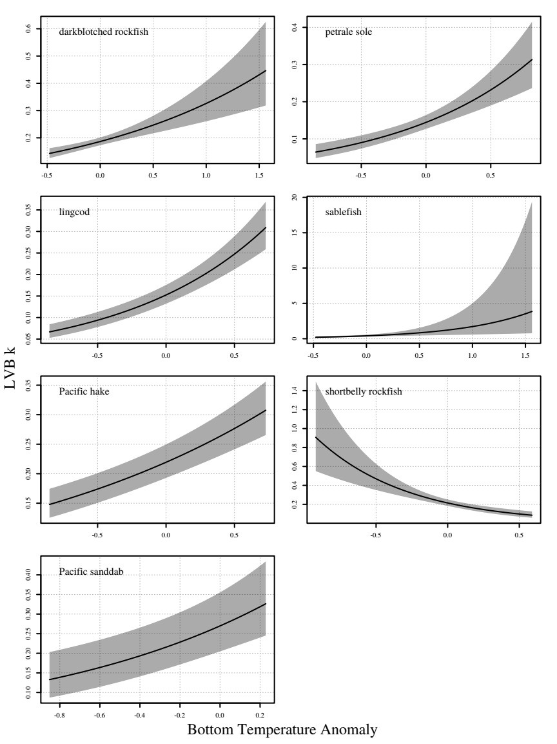

Supplemental Materials

Figure S1. Empirical mean length at ages 1 to 9 (across rows from top left to bottom right) and predicted length at age from the best fitting model for darkblotched rockfish.

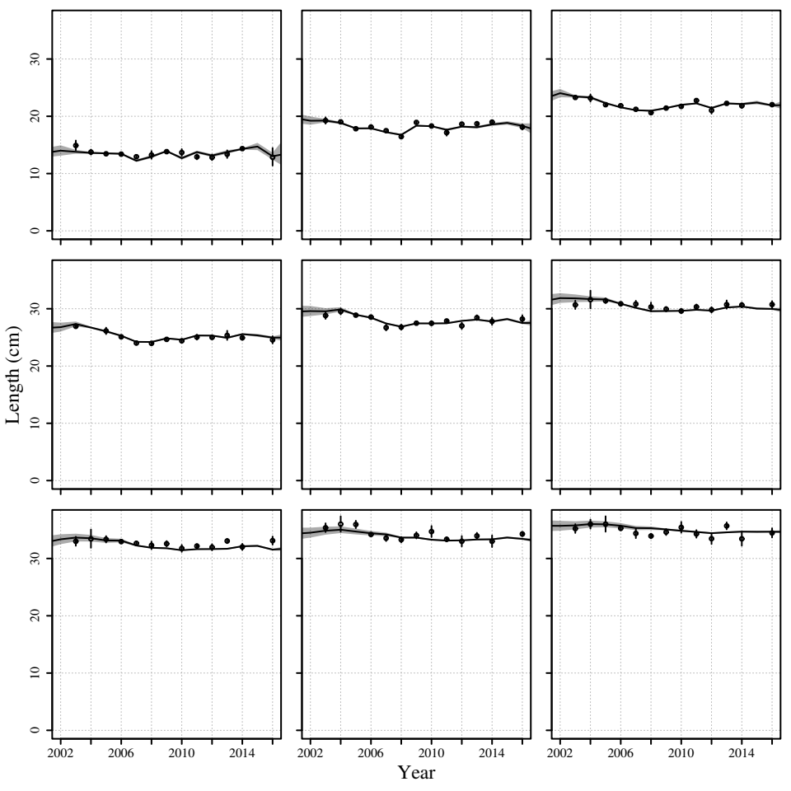

Figure S2. Empirical mean length at ages 1 to 9 (across rows from top left to bottom right) and predicted length at age from the best fitting model for lingcod.

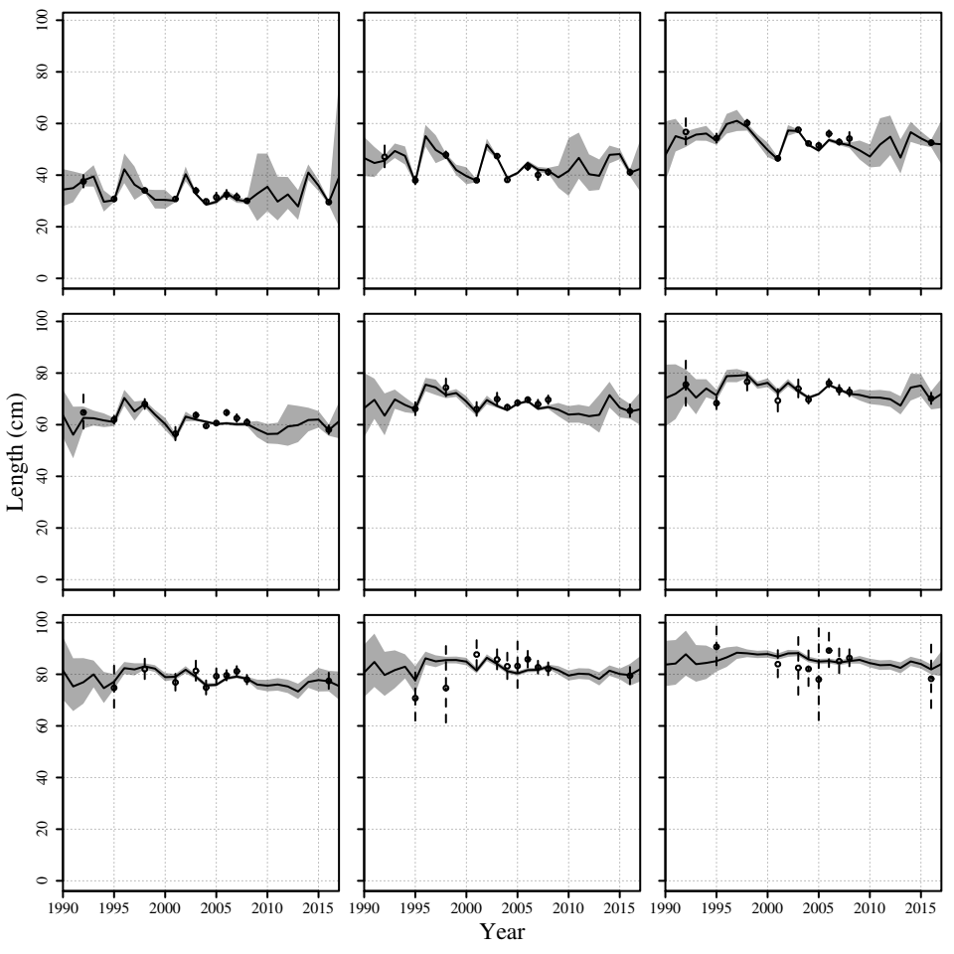

Figure S3. Empirical mean length at ages 1 to 9 (across rows from top left to bottom right) and predicted length at age from the best fitting model for Pacfic hake.

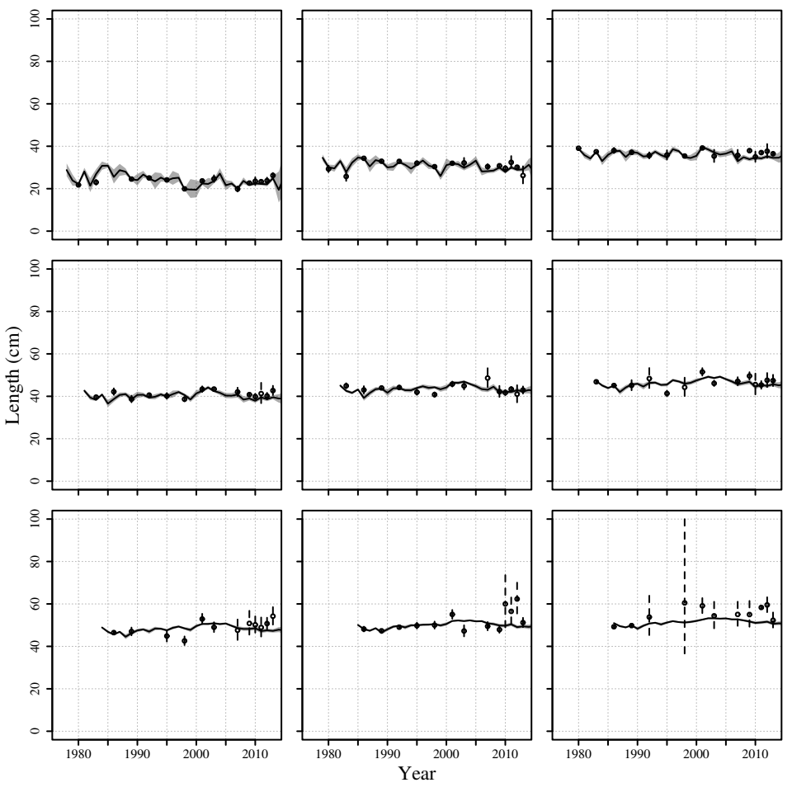

Figure S4. Empirical mean length at ages 1 to 9 (across rows from top left to bottom right) and predicted length at age from the best fitting model for Pacifc sanddab.

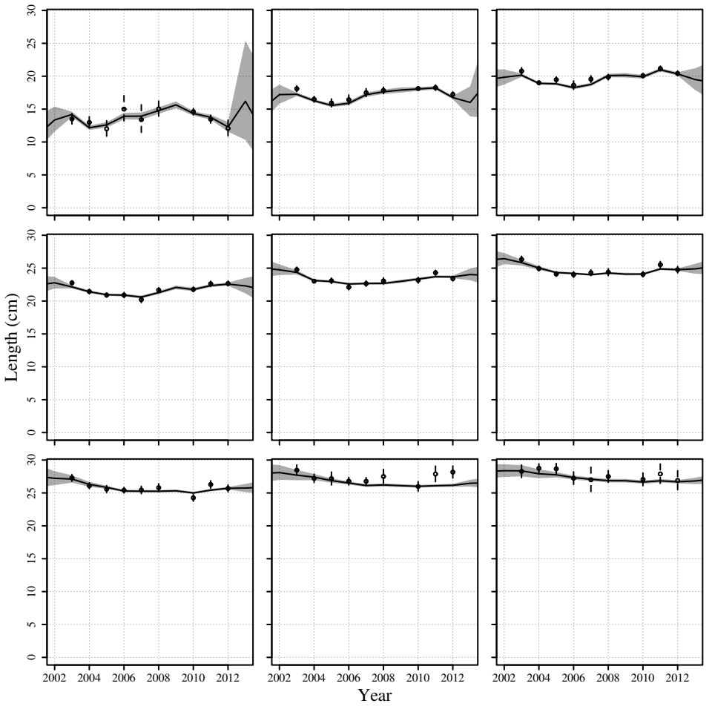

Figure S5. Empirical mean length at ages 1 to 9 (acros rows from top left to bottom right) and predicted length at age from the best fitting model for Petrale sole.

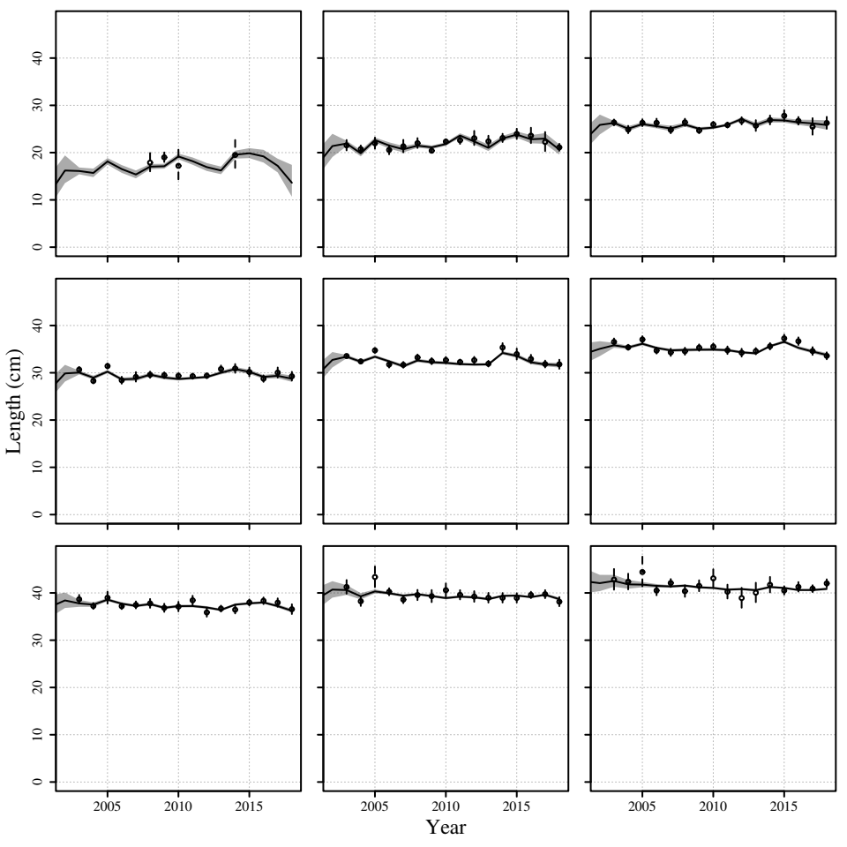

Figure S6. Empirical mean length at ages 1 to 9 (across rows from top left to bottom right) and predicted length at age from the best fitting model for sablefish.

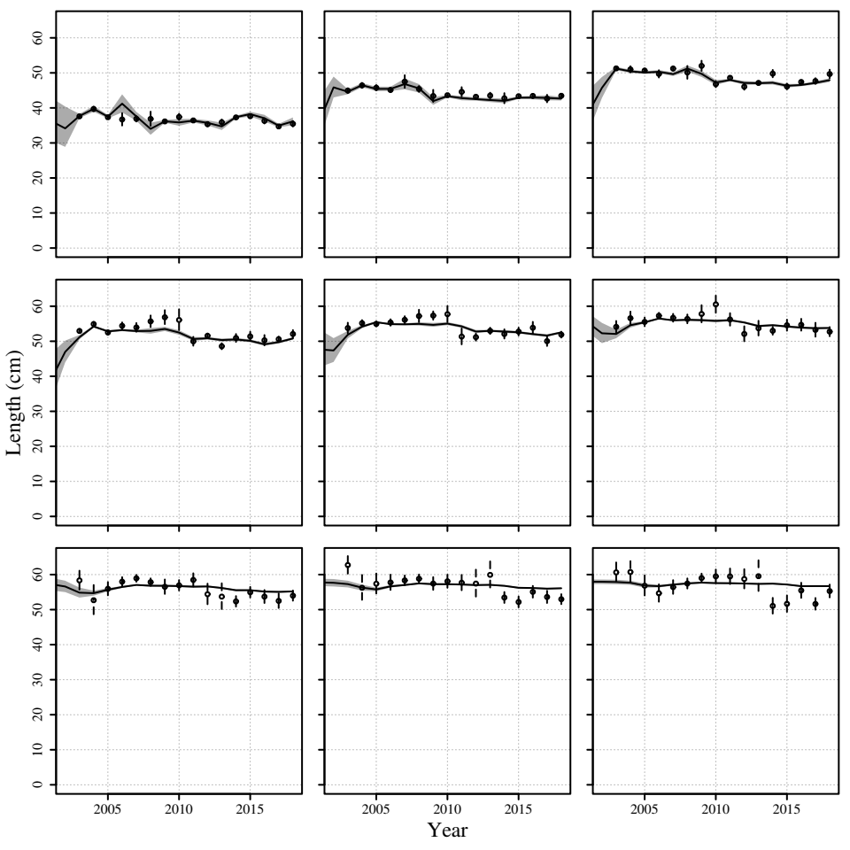

Figure S7. Empirical mean length at ages 1 to 9 (across rowss from top left to bottom right) and predicted length at age from the best fitting model for shortbelly rockfish.

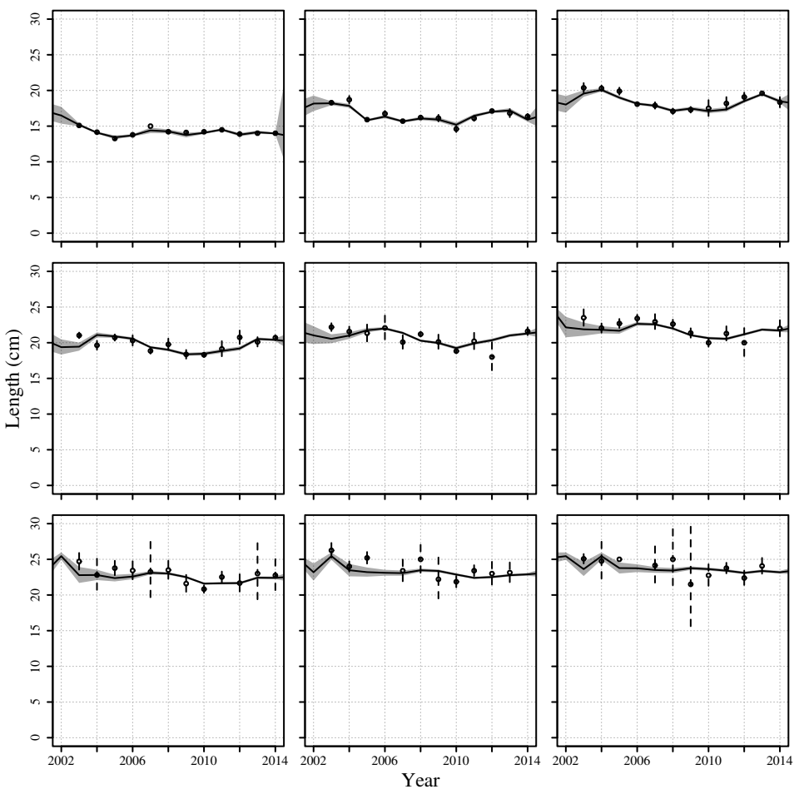

Figure S2.

Angilletta, M.J., Steury, T.D., and Sears, M.W. 2004. Temperature, Growth Rate, and Body Size in Ectotherms: Fitting Pieces of a Life-History Puzzle. Integrative Comparative Biology **44**: 498-509.

Audzijonyte, A., Richards, S.A., Stuart-Smith, R.D., Pecl, G., Edgar, G.J., Barrett, N.S., Payne, N., and Blanchard, J.L. 2020. Fish body sizes change with temperature but not all species shrink with warming. Nature ecology & evolution **4**(6): 809-814.

Baudron, A.R., Needle, C.L., and Marshall, C.T. 2011. Implications of a warming North Sea for the growth of haddock Melanogrammus aeglefinus. J Fish Biol **78**(7): 1874-1889.

Baudron, A.R., Needle, C.L., Rijnsdorp, A.D., and Marshall, C.T. 2014. Warming temperatures and smaller body sizes: synchronous changes in growth of North Sea fishes. Glob Chang Biol **20**(4): 1023-1031.

Black, B.A. 2009. Climate-driven synchrony across tree, bivalve, and rockfish growth-increment chronologies of the northeast Pacific. Marine Ecology Progress Series **378**: 37-46.

Brander, K.M. 1995. The effect of temperature on growth of Atlantic cod (*Gadus morhua*). ICES Journal of Marine Science **52**: 1-10.

Brodie, S.J., Thorson, J.T., Carroll, G., Hazen, E.L., Bograd, S., Haltuch, M.A., Holsman, K.K., Kotwicki, S., Samhouri, J.F., Willis‐Norton, E., and Selden, R.L. 2020. Trade‐offs in covariate selection for species distribution models: a methodological comparison. Ecography **43**: 11-24.

Brunel, T., and Dickey-Collas, M. 2010. Effects of temperature and population density on von Bertalanffy growth parameters in Atlantic herring: a macro-ecological analysis. Marine Ecology Progress Series **405**: 15-28.

Burnham, K.P., and Anderson, D.R. 2002. Model selection and multimodel inference: a practical information-theoretic approach. Springer-Verlag, New York.

Cheung, W.W.L., Sarmiento, J.L., Dunne, J., Frölicher, T.L., Lam, V.W.Y., Deng Palomares, M.L., Watson, R., and Pauly, D. 2013. Shrinking of fishes exacerbates impacts of global ocean changes on marine ecosystems. Nature Climate Change **3**(3): 254-258.

Daufresne, M., Lengfellner, K., and Sommer, U. 2009. Global warming benefits the small in aquatic ecosystems. Proc Natl Acad Sci U S A **106**(31): 12788-12793.

Essington, T.E., Kitchell, J.F., and Walters, C.J. 2001. The von Bertalanffy grovuth function, bioenergetics, and the consumption rates of fish. Canadian Journal of Fisheries and Aquatic Sciences **58**: 2129-2138.

Fontoura, N.F., and Agostinho, A.A. 1996. Growth with seasonally varying temperatures: an expansion of the von Bertalanffy growth model. Journal of Fish Biology **48**: 569-584.

Forster, J., and Hirst, A.G. 2012. The temperature-size rule emerges from ontogenetic differences between growth and development rates. Functional Ecology **26**(2): 483-492.

Forster, J., Hirst, A.G., and Atkinson, D. 2011. How do organisms change size with changing temperature? The importance of reproductive method and ontogenetic timing. Functional Ecology **25**(5): 1024-1031.

Guillera-Arroita, G., Lahoz-Monfort, J.J., Elith, J., Gordon, A., Kujala, H., Lentini, P.E., McCarthy, M.A., Tingley, R., and Wintle, B.A. 2015. Is my species distribution model fit for purpose? Matching data and models to applications. Global Ecology and Biogeography **24**(3): 276-292.

Katsanevakis, S., and Maravelias, C.D. 2008. Modelling fish growth: multi-model inference as a better alternative to *a priori* using von Bertalanffy equation. Fish and Fisheries **9**: 178-187.

Kimura, D.K. 2008. Extending the von Bertalanffy growth model using explanatory variables. Canadian Journal of Fisheries and Aquatic Sciences **65**(9): 1879-1891.

Lester, N.P., Shuter, B.J., and Abrams, P.A. 2004. Interpreting the von Bertalanffy model of somatic growth in fishes: the cost of reproduction. Proceedings of the Royal Society B: Biological Sciences **271**(1548): 1625-1631.

Miller, T.J., O’Brien, L., and Fratantoni, P.S. 2018. Temporal and environmental variation in growth and maturity and effects on management reference points of Georges Bank Atlantic cod. Canadian Journal of Fisheries and Aquatic Sciences **75**(12): 2159-2171.

Quince, C., Abrams, P.A., Shuter, B.J., and Lester, N.P. 2004. Biphasic growth in fish I: Theoretical foundations. Journal of theoretical biology **254**: 197-206.

Quinn, T.J., and Deriso, R.B. 1999. Quantitative Fish Dynamics. Oxford University Press, New York.

Schnute, J., and Fournier, D. 1980. A new approach to length-frequency analysis: growth structure. Canadian Journal of Fisheries and Aquatic Sciences **39**(9): 1337-1351.

Shin, Y.-J., and Rochet, M.-J. 1998. A model for the phenotypic plasticity of North Sea herring growth in relation to trophic conditions. Aquatic Living Resources **11**: 315-324.

Stawitz, C.C., Essington, T.E., Branch, T.A., Haltuch, M.A., Hollowed, A.B., and Spencer, P.D. 2015. A state-space approach for detecting growth variation and application to North Pacific groundfish. Canadian Journal of Fisheries and Aquatic Sciences **72**(9): 1316-1328.

Thorson, J.T. 2019. Guidance for decisions using the Vector Autoregressive Spatio-Temporal (VAST) package in stock, ecosystem, habitat and climate assessments. Fisheries Research **210**: 143-161.

von Bertalanffy, L. 1938. A quantitative theory of organic growth. Human Biology **10**: 181-213.

Whitten, A.R., Klaer, N.L., Tuck, G.N., and Day, R.W. 2013. Accounting for cohort-specific variable growth in fisheries stock assessments: A case study from south-eastern Australia. Fisheries Research **142**: 27-36.